**ECEN403 Validation Document – Power and Mechanical Subsystem**

**Power System Diagram:**

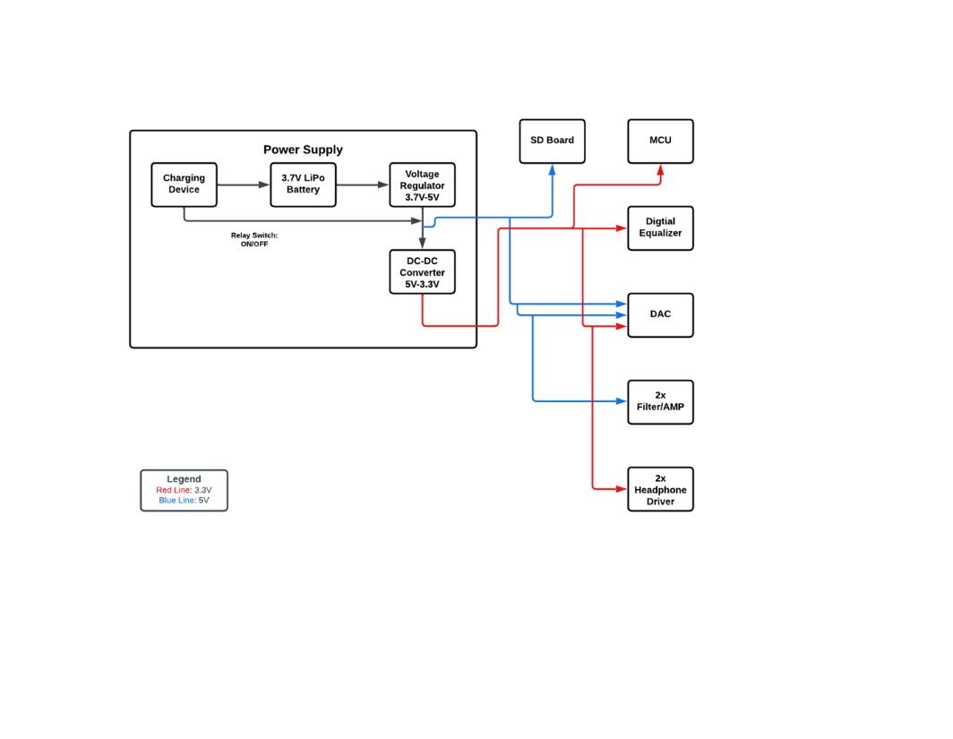

**Voltage Regulator (5V output):**

Simulations:

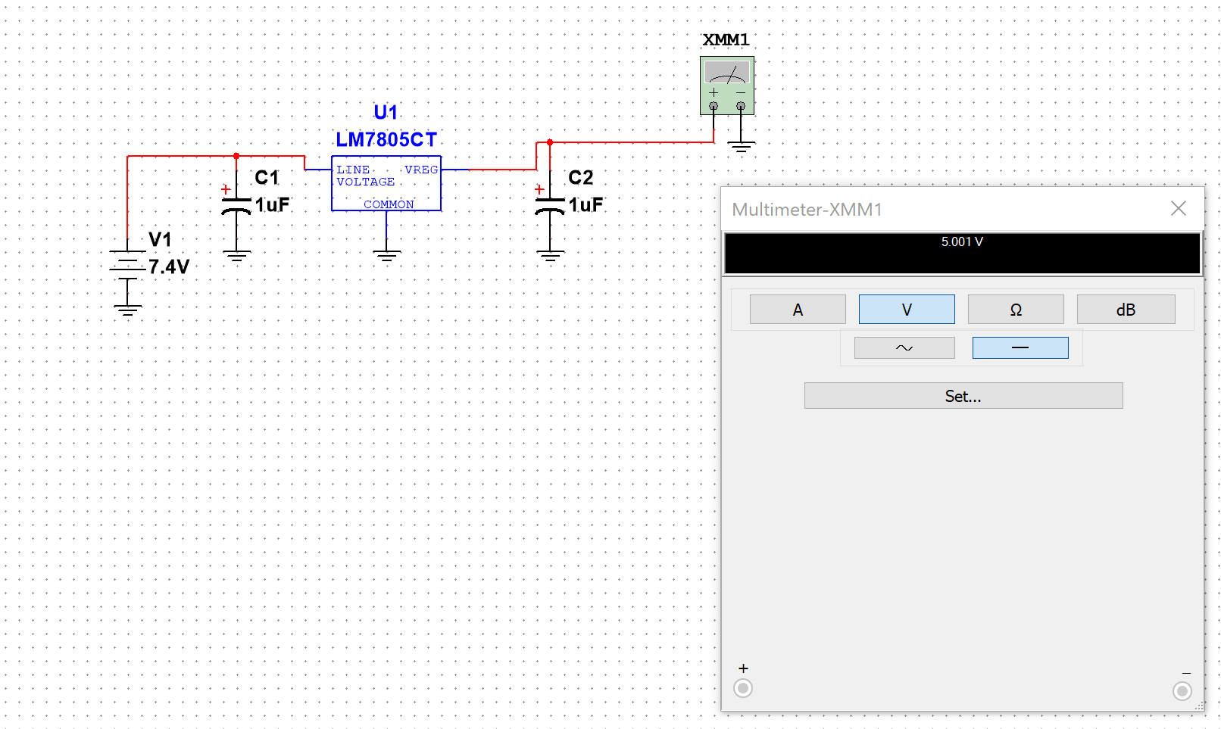

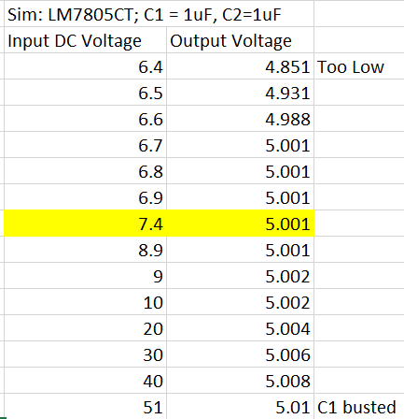

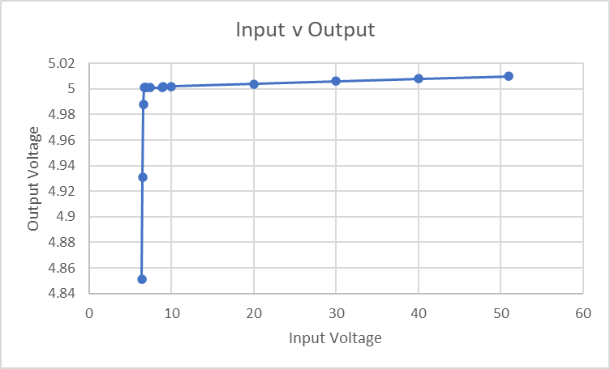

Measurements:

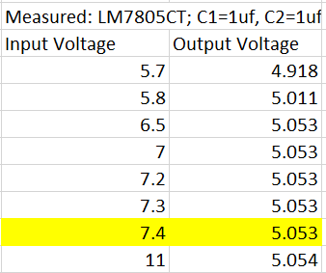

**Buck Converter (3.3V output):**

Calculations:

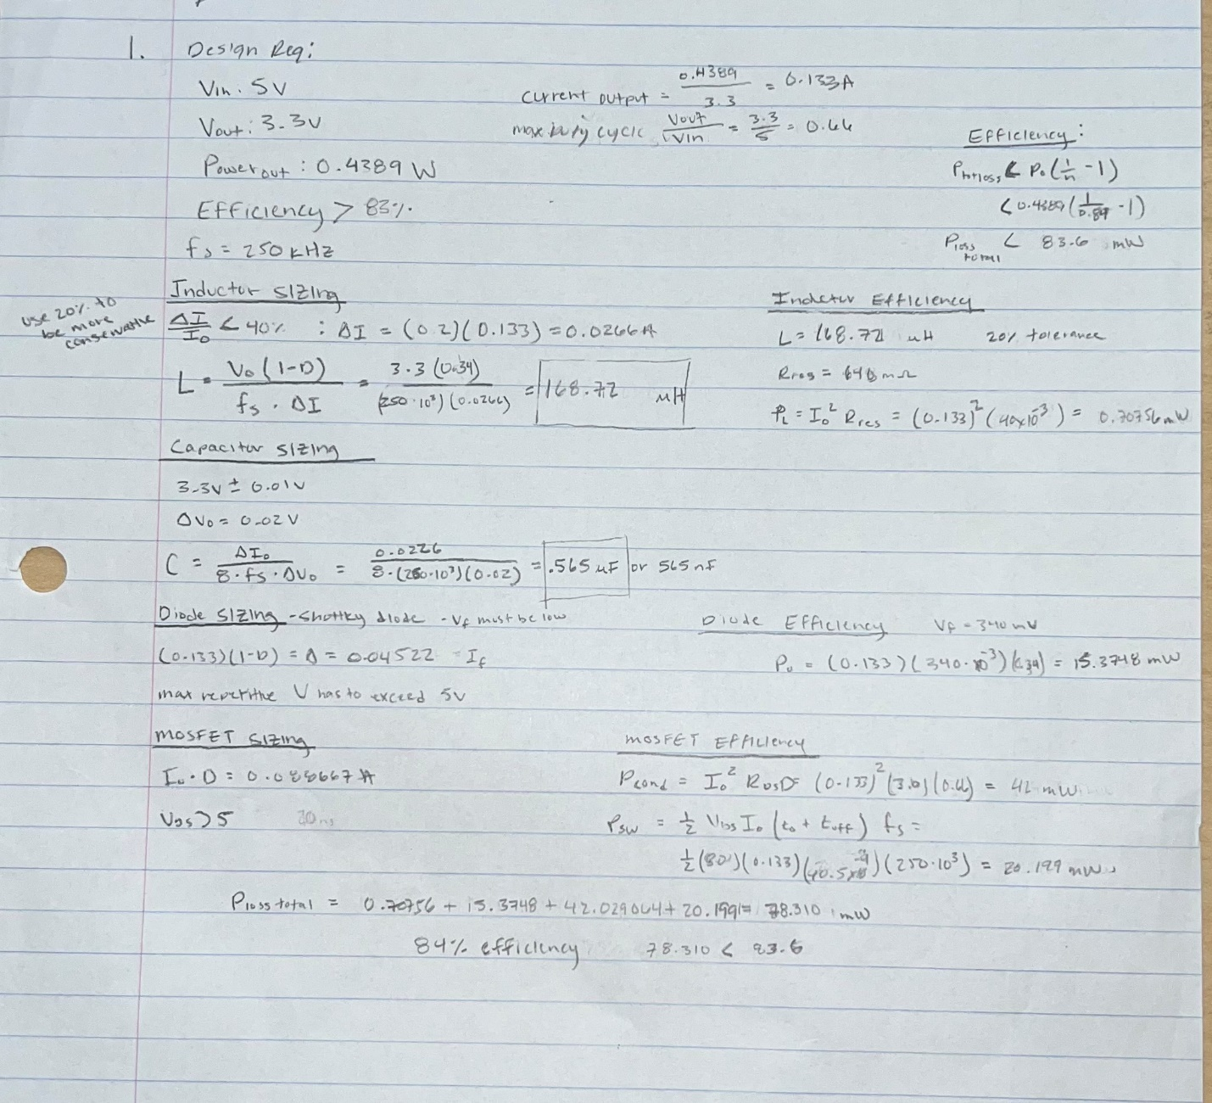

Calculations include: Vin, Vout, Load Power, Load Current, Switching frequency, Duty Cycle, Component Sizing (Inductor, Capacitor, Diode, MOSFET), and Power Loss Efficiency

Simulations:

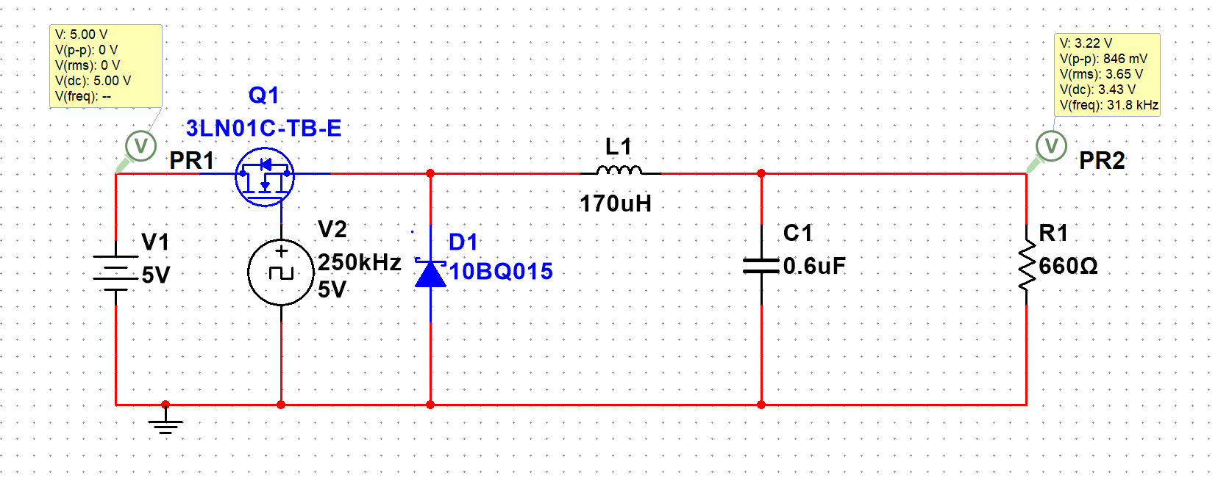

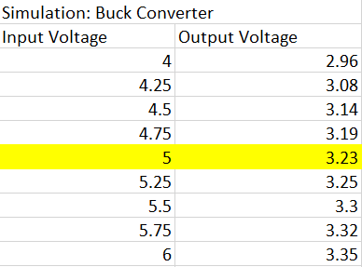

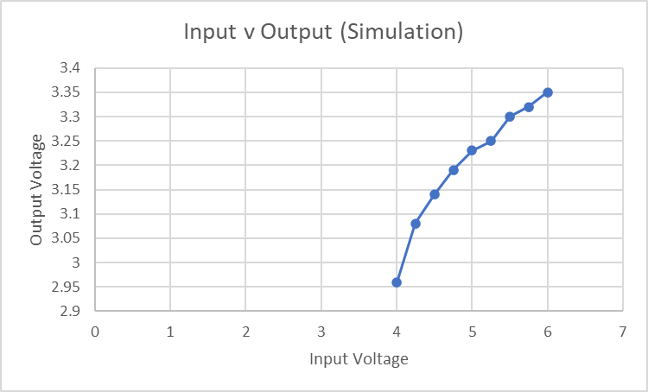

Measurements:

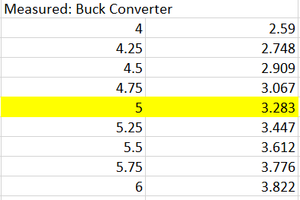

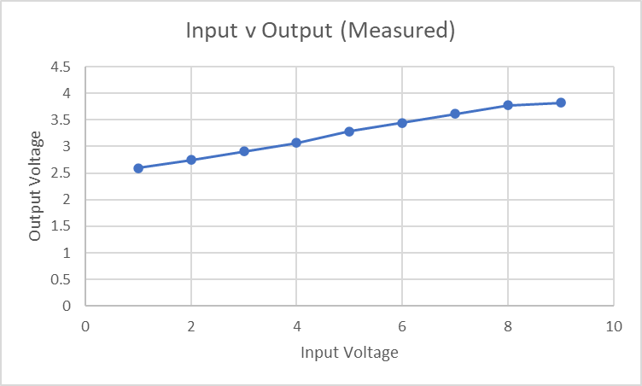

**PCB Design:**

Schematic:

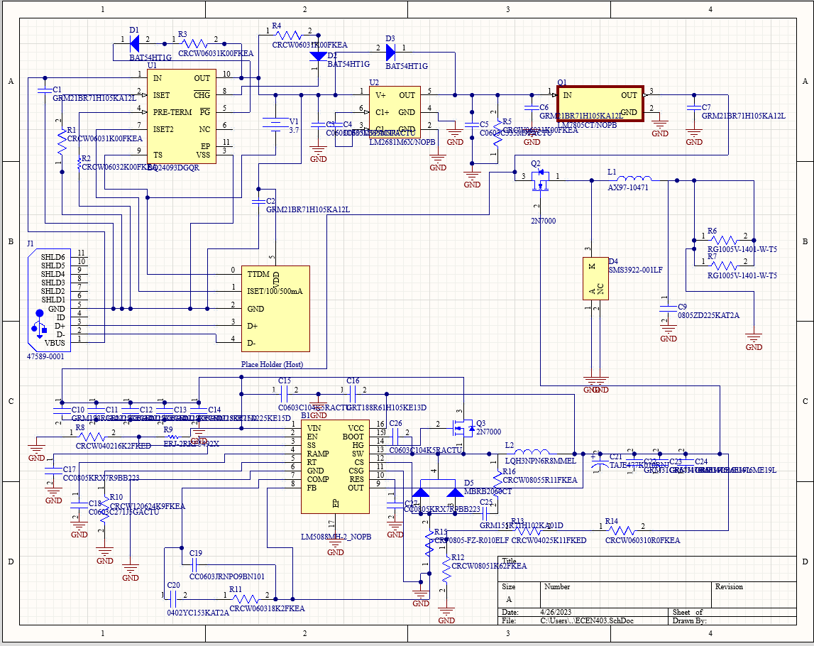

PCB Layout:

